CRM Project

Functional Specification - Enhancement

PP6

CRM.PP6.CM-090-160-020-E.CM_ENH_130- Contract Mgt Change New Contract

(Object id: CM_ENH_130)

Deliverable Name | PP6 Enhancement Functional Specifications
Date | 01/06/11
Revision | V3.0
Signed off By
Signoff Date

TABLE OF CONTENTS

1. Version 2
2. Approvals 3
3. Priority Mention the Priority of the object from the FRICEW list in ILM. Processing Mode (check all that apply) 3
Low Medium High 3
4. Enhancement Requirements Description 3
5. Impacted Systems 4
6. Approach to be followed < List the type of enhancement whether it is a user exit, BADI or Custom transaction> 4
7. Roles and Volumes 4
8. Security & Control Requirements 5
8.1 Security Requirements 5
8.2 Control/Audit Requirements – N/A 5
9. Dependencies 5
9.1 Development Dependencies 5
9.2 Run/Execution Dependencies – N/A 6
9.3 Archiving Dependencies – N/A 6
10. Execution Steps 6
10.1 Process Description 6
10.2 Process Flow 6
10.3 As-Is Systems Referred To 7
10.4 Processing Options 7
11. Enhancement Description 8
11.1 Detailed Description of the Enhancement 8
11.2 UI Design and Screen Flow < Mention the WEBUI Design in the sense the mock up screens and the navigation flow between the screens etc> 13
11.3 Access Method or Path for Enhancement 14
11.4 Required Custom Tables (if known) - NA 14
11.5 Error Handling Rules 14
12. Enhancement Reconciliation & Testing Requirements 15
12.1 Data Validation 15
12.2 Testing Reconciliation - N/A 15
12.3 Performance Issues – N/A 15
13. Additional Information – N/A 15
14. Open Items- N/A 15
15. Functional Unit Test cases <Here they should list the possible test scenarios in the table below> 15

Version
Ensure that any approved change requests that affect scope are documented in the revision history and include CR #.
Version | Change Description | Author | Date Released | Sections Impacted
Enter in the version number | Brief description of the change | Who made the change | Date change was made | Mention the sections impacted with this change
1.0 | Initial creation | Cecilia Shepherd | 11/29/10
2.0 | Added volume | Cecilia Shepherd | 12/7/10 | 7
3.0 | Added business roles in section 7, added details contract header definition, if account has already been final billed, do not allow change in the contract end date, added error handling rules, corrected the numbers for section 12.4 forward, added FUT relating to change in start date and the effect on forced move out contracts | Cecilia Shepherd | 01/04/11 | 6, 7, 11.1, 11.4, 12, 13, 15
4.0 | Finish Process Interaction Record update, page 12 | Judy Jarone | 02/17/2011 | 11.1
5.0 | Change Request CHG03978 – Revert to standard CRM Change Contract Process | Judy Jarone | 5/16/2011 | 4.0, 6,0, 11, 11.1, 15
5.1 | Include reference to changes related to CRM.PP6.CM-050-050-090-E.CM_ENH_070-Rate Change Navigation & View Enhancements | Judy Jarone | 5/23/2011 | 11.1 (pg 9)
5.2 | Change Request CHG04490 – Remove Combo Account alert | Judy Jarone | 12/06/2011 | 11.1 (pg 9), 15 (pg 16)

Approvals
The individuals listed below will be required to review and approve this document.
Reviewers Title | Reviewer Role | Name
Project Title of Reviewer | Reviewer's Role (Responsible, Approve, Consult, Inform) | Reviewer's Name
CRM Functional Team Lead | Approve | Robert Smeltekop
Technical Team Lead | Approve | V. Krishna Karunakaram

Priority
Mention the Priority of the object from the FRICEW list in ILM.
Processing Mode (check all that apply)

Low Medium High

Enhancement Requirements Description

<This section should contain a detailed description of the business requirements for this enhancement in business terms. Please insert any description of the business flow which would aid in understanding this process.>

Once a New Contract has been created or ended a customer may request the contract dates to be adjusted and/or a meter read entered. The Change Contract process allows the user to perform these actions based on the status of the individual contract.

The objective of this enhancement is to provide additional functionality to the standard Change Contract process to avoid additional manual updates to the contract. View enhancements required for Contract Changes will be detailed in this PP6.

The Change Contract process will allow the user to modify the contract start dates, contract end dates, meter reads as well as maintain the product and product related billing attributes. Enhancements to product change and product attributes can be found in CRM.PP6.CM-050-050-090-E.CM_ENH_070-Rate Change Navigation & View Enhancements.

Impacted Systems

<This list should include systems that are being impacted as a result of this enhancement.>

CRM 7.0 Web IC : CRM 7.0 Web Client Interaction Center Production System
ECC 6.0 / IS-U ECC 6.0 / IS-U : Back End Production System (Enterprise Central Component)

Approach to be followed
< List the type of enhancement whether it is a user exit, BADI or Custom transaction>

The existing Contract Management Search view will be enhanced so that when the agent navigates to this view, the search fields will be hidden and the Result List will automatically be populated with the Contract/s relating to the confirmed account or premise. The hyperlink Show Search Fields will still be available to the agent.

The Result List view will be enhanced to add the following buttons: Cancel Contracts and Change Contract. Refer to CM-090-160-080-E Contract Mgt Cancel New Contract, CM-090-160-200-E Contract Mgt Cancel End Contract and CRM.PP6.CM-050-050-090-E.CM_ENH_070-Rate Change Navigation & View Enhancements for the enhancements relating to the Cancel Contracts and Change Contracts button respectively. The following buttons will be removed: Move to Premise and Create Quotation.

Roles and Volumes
<Describe information regarding users and volumes. Make sure to note if the use of this development will require additional communication and/or training. Also, specify what the volume requirements will be needed by the Go-Live date.

Complete the table below with the correct project-specific information for this functional specification. Instructions are in the middle row, and a sample entry is in the bottom row.>
Role | Estimated Volume Requirement | Comments
List name of role; should come from the list of security roles | Enter the estimated volume requirements that will be needed by the Go-Live date | Enter other comments including if this development will require additional communication and/or training
CSR 2, 3, 4, VCC MGMT | 1,000,000 / Year
BCOS | +- 75 / Day
Billing | +- 75
Consumer Affairs | +- 75
Revenue Recovery | +- 75

Security & Control Requirements

Security Requirements
<Describe any security requirements that need to be put in place as a result of this development object. This could include security access to affected transactions or new transactions that may result from this development. If the enhancement has to be archive enabled, list additional security to be added to the roles.> NA

Control/Audit Requirements – N/A
Describe any control requirements that need to be put in place as a result of this development object>.
•€€€€€€€€ If applicable, please answer the question and also provide detail to the question .
•€€€€€€€€ The questions listed below are not all inclusive to the control requirement that may be required. If there are any other controls requirements please document them as well.
▪ Indicate if this enhancement is being developed to address a control requirement?
▪ Financial/SOX Impact - Does the enhancement have any impact to financial reporting? If yes, is the amount significant (i.e. greater than $35 million annually)? Please provide an estimate.
▪ Regulatory Impact - Does the enhancement have any impact to regulatory compliance (i.e. FERC, NERC, etc)? If yes, please provide a reference to the rule and describe the impact.
▪ Operational Impact - Is the enhancement relied upon for a mission critical process or providing services to customers? If yes, please identify the mission critical process and describe how this enhancement is used in the context of this process.

Dependencies

Development Dependencies
<List the configuration, development, and other work that must be considered during the creation of this enhancement.>
CRM.PP6.CM-050-050-090-E.CM_ENH_070-Rate Change Navigation & View Enhancements for the Cancel Contract and Other Changes button respectively.

Run/Execution Dependencies – N/A
<Once in production, this development object may need to be executed before or after another system event. List other system events that this development object should follow or precede. If the enhancement is to be archived enabled, does it need to have adequate archived sessions, info structures, etc established in order to test/execute.>

Archiving Dependencies – N/A
<List how the changes would impact archiving, if the enhancement impacts existing archived objects (i.e. table structures). Also list what needs to be regression tested from an archiving perspective.>

Execution Steps

Process Description
<Explain the process for when this development object will be used. If this is tied back to a certain task within a process you may insert the Task Profile document here as well.

Enter any of the following information available:
- Transaction Code
- User Exits
- Performance Consideration
- Z Tables created
- Code reuse.

The Change Contract process will be accessed through the CRM IC Web Navigation bar.

Process Flow
<Create a diagram that visually depicts the process.>

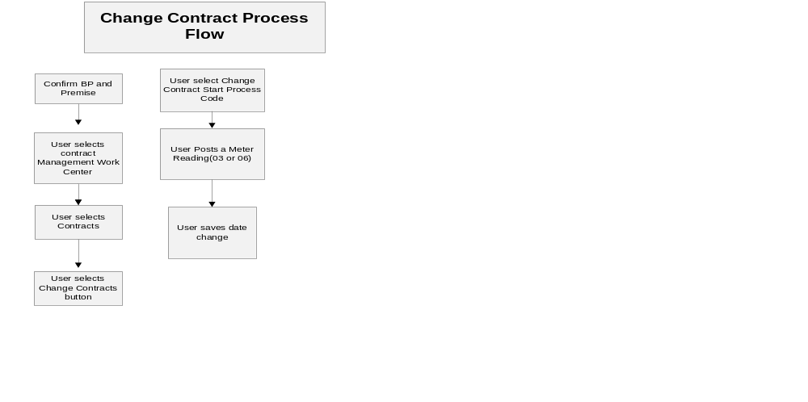

As-Is Systems Referred To
<List the systems that the task pertaining to this development object is performed in. If this is a new task (i.e. not being performed today), list it ‘Not applicable’.>

Execute CICO in ECC, select ZMIDATE front office process to change move-in date and select ZMIEDIT front office process to change move-in document.

Processing Options
<Indicate the Processing Mode, Frequency, and Lifetime of Development by selecting and placing an ‘X’ in the box next to the correct options below. Right click on the gray box, select properties, and specify “Checked”.>
Processing Mode (Select one of the following)
Batch Online – via Transaction Code Online – via Menu Path
On demand

Frequency (Select one of the following)
Daily
Weekly Quarterly
Monthly Annually
Other (If other, describe here)

Lifetime of Development (select one)
Permanent
Temporary, e.g. until rollouts are complete, specify details here

Enhancement Description

The existing Contract Management Search view will be enhanced such that when a user navigates to this view, the search fields will be hidden and the Result List will automatically be populated with the Contract/s relating to the confirmed account and premise. The hyperlink Show Search Fields will be available to the agent if required.

An enhancement will be made to the Result List to alert the user when selected contracts do not share the same header and the user selects the Cancel Contract button. Refer to CM-090-160-080-E Contract Mgt Cancel New Contract, and CM-090-160-200-E Contract Mgt Cancel End Contract for detailed functional requirements. The Move to Premise and Create Quotation buttons will be removed.

An enhancement will be made to the Contract Start Date process code to adjust force ended contract that has not been billed.

An enhancement will be made to allow the user to ‘Release’, ‘Estimate’, ‘Enter’ meter readings associated with the Change Contract process. The view will be enhanced to view meter reading history allowing the user to filter as required. The view will have the same functionality as the End Contract and New Contract Meter Reading views with the exception of the Meter Read reason. An enhancement will be made to only maintain 03 (End Contract) and 06 (New Contract) Meter reads within the change contract process.

Detailed Description of the Enhancement

<Provide a written description of the functionality that needs to be developed. Identify/describe the SAP application transaction that uses or is used to invoke the enhancement. Describe tables, transactions, reports, forms, screens and other objects that need to be created or modified. Insert a Visio flow diagram of the process to be executed by the enhancement, and add any other information required to develop the enhancement.>

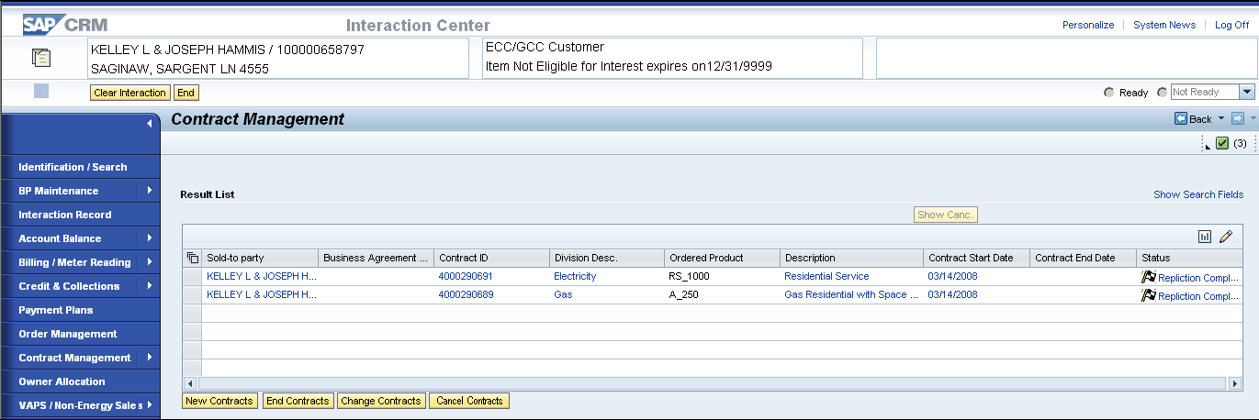

The existing Contract Management Search view will be enhanced so that when the agent navigates to this view, the search fields will be hidden and the hyperlink to Show Search Fields will be available on the top of the Result List. The Result List will automatically be populated with the Contract/s relating to the confirmed account or premise. If the agent did not confirm an account or a premise, the Result list will be blank and the agent will have to click on the Show Search Fields to enter the search criteria to find a contract.

The Result List view (Component = IUICCON, view = Contract List) will be enhanced to add the following buttons: Cancel Contracts and remove the Move to Premise and Create Quotation buttons.

An enhancement will be made to the Result List (Component = IUICCON, view = Contract List) to allow the agent to select multiple contracts that belong to the same header record to Cancel Contracts. The ViewSet, ContractSearchVS, will also be enhanced to remove the Risk Rating view that is delivered standard with this ViewSet.

- When a contract is created a header record is created with one or more items/contracts (one for electric, one for gas). Select the GUID field from table CRMD_ISUEXTA4 for each contract in question. Go to table CRMD_ORDERADM_I with that GUID (same field name on both tables) and select the HEADER field. A match indicates that the contracts are part of the same header record.
If the agent selects multiple contracts from the Result List, it should validate if the Contracts belong to the same header record. If the Contracts do not belong to the same header record, the End Contract and Cancel Contract buttons will be disabled. It should send the following system error message: Please select Contracts that belong together.

- The Cancel End and Cancel Contract process functions will be removed from the drop down list of process codes leaving only Change New Contract, Change End Contract and product related functionality associated with CRM.PP6.CM-050-050-090-E.CM_ENH_070-Rate Change Navigation & View Enhancements.

- If the Change Contract End process is selected and the final bill has already been created for the account, then it must not allow the agent to change the Contract End Date and must display the following error message: Bill Reversal needed first. Account has already been issued a final bill.

Else If the change is relating to the Contract Start Date and

If the contract on the premise had a Force Move-out (this field is available in ECC with MoveOutForced flag) check if it had already been final Billed. If no billing has occurred then change the Force Ended Contract date to New Contract Start Date – 1. If billing has occurred it must display the following warning message: There was a force move-out as a result of this contract that has been final billed. Please cancel the final bill and manually make corrections to the Force Ended Contract.

- If the change contract process is selected and the user selects the Meter Data button then the user will be able to modify contract related meter readings provided no billing has occurred.

CHANGE CONTRACT START DATE:

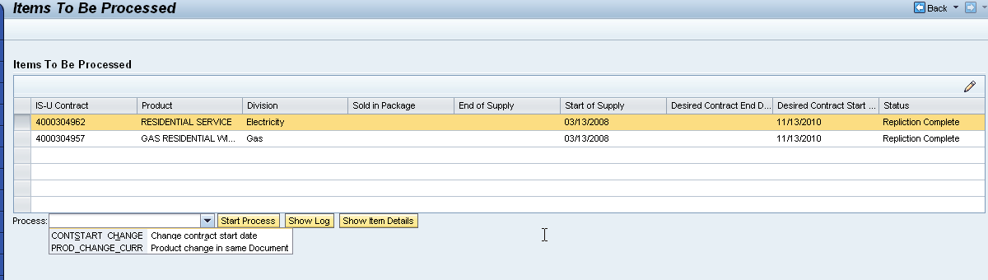

The user will select the Contract from the Items list (Component = IUICCON, view = ContractList) and press the ‘Start Process’ button.

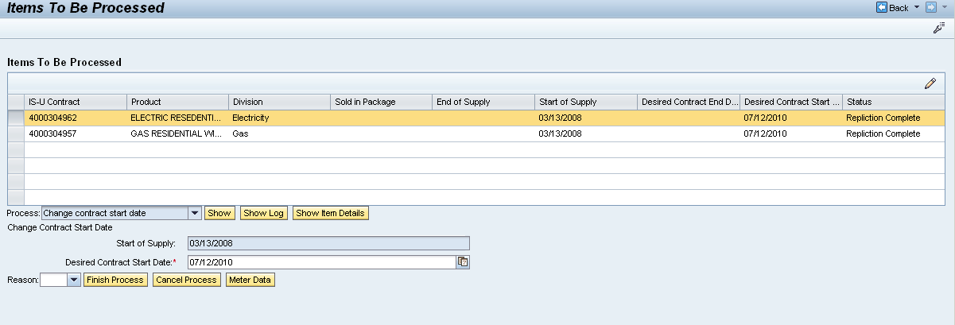

The user can select the ‘Finish Process’ button once the Desired Contract Start Date is applied. If the previous contract on the premise was Force Ended and no billing has occurred then update the previous contract’s end date equal to the New Contract Start Date - 1 day.

CHANGE METER READING RESULTS (Create Contract):
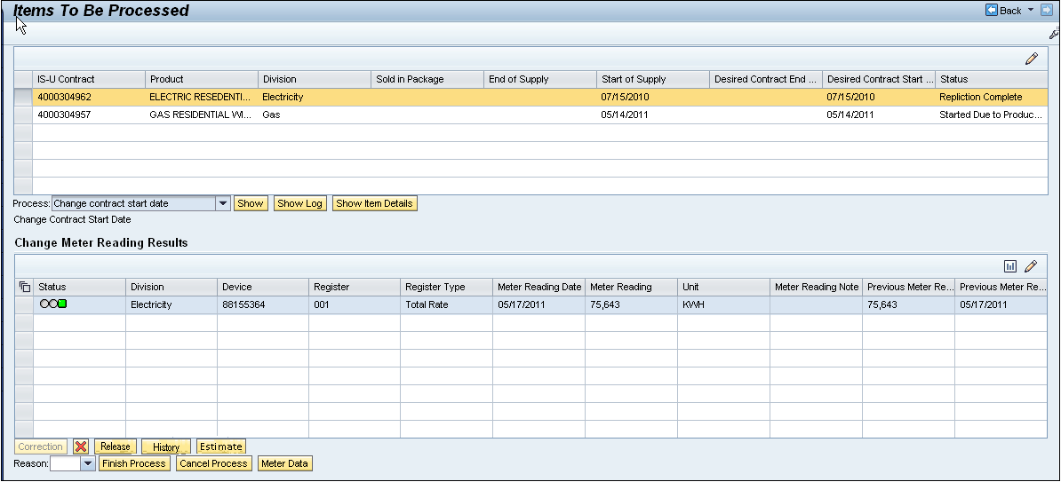

The user can select the ‘Meter Data’ button instead of the change the contract start date and process meter reading orders with meter reading reason 06 (move-in).

The view (Component = IUICMRD, view = IUICMRD/MeterReading) will be enhanced to display only meter reads with read reason = 06 (Move-in) with a meter read date equal to the Contact Start date. The ability to edit the reads will be dependent upon billing. If subsequent billing has occurred, the meter reading will be display only and all buttons will be disabled with the exception of the History button.

The view will be enhanced with the addition of the following functions:
            - Meter Read Date – The meter reading date should change to equal the Contract Start Date.
            - Meter Read Validation – No change to standard SAP validation
            - Meter Read Estimation – No Change to standard SAP estimation
            - Meter Read Release - See functionality developed in (PP6) CM-050-70-030-E Enter Meter Read & Perform Corrections (CM_ENH_1770). Add the ‘Release’ button to view
            - Meter Read History – No Change to the standard SAP.

CHANGE CONTRACT END DATE:
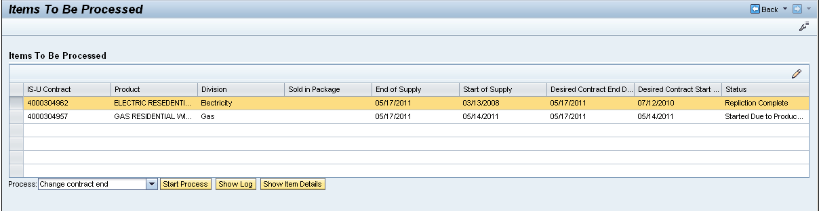

The user will select the Contract from the Items list (Component = IUICCON, view = ContractList), Select Process ‘Change Contract End’ and press the ‘Start Process’ button. The standard view below will be used to change the Contract End date and/or post 03 meter readings.

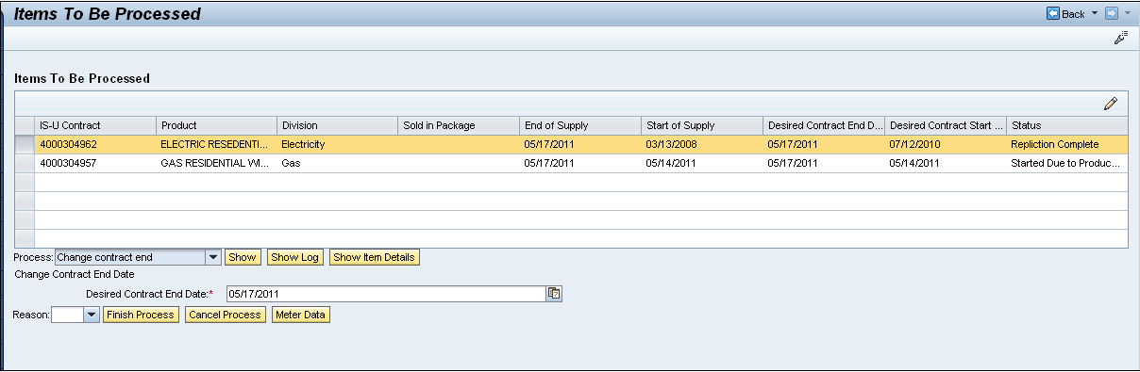

CHANGE METER READING RESULTS (End Contract):
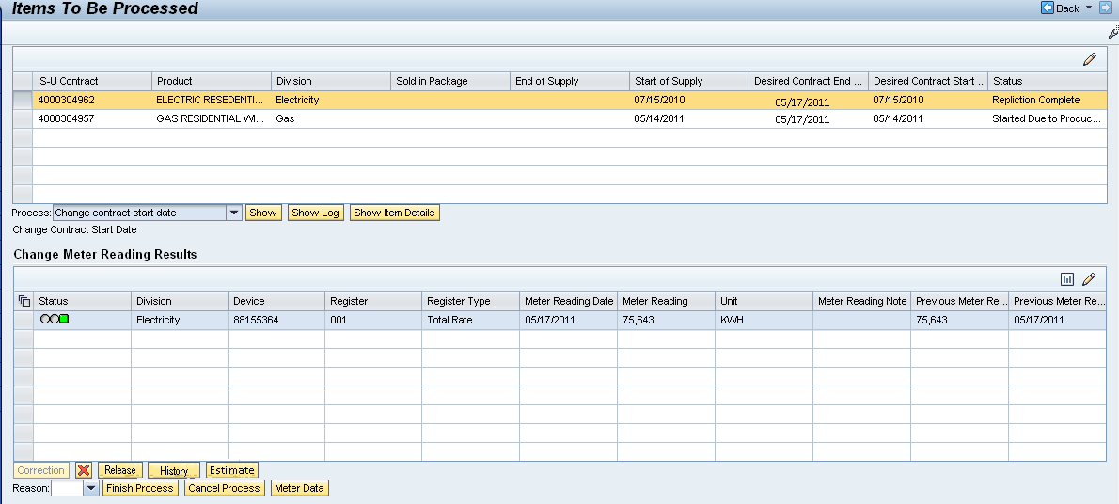

If the Contract End Date was modified, then the Meter Read dates will be adjusted accordingly. The user can select the ‘Meter Data’ button instead of the change the contract start date and process meter reading reason 06 (move-in) meter reading orders.

The view (Component = IUICMRD, view = IUICMRD/MeterReading) will be enhanced to display only meter reads with read reason = 03 (Move-out) with a meter read date equal to the Contact End Date. The ability to edit the reads will be dependent upon billing. If subsequent billing has occurred, the meter reading will be display only and all buttons will be disabled with the exception of the History button.

The view will be enhanced with the addition of the following functions:
            - Meter Read Date – The meter reading date should change to equal the Contract Start Date.
            - Meter Read Validation – No change to standard SAP validation
            - Meter Read Estimation – No Change to standard SAP estimation
            - Meter Read Release - See functionality developed in (PP6) CM-050-70-030-E Enter Meter Read & Perform Corrections (CM_ENH_1770). Add the ‘Release’ button to view
            - Meter Read History – No Change to the standard SAP.

FINISH PROCESS/CANCEL PROCESS

When the Finish Process button is clicked by the agent, the system must use the standard delivered functionality of changing the contract and updating the meter read. Refer to component = IUPRMAIN, viewset = MainVS.

Change Contract End Interaction Record.
Once the Finish Process button has been selected the following will be written to the Interaction Record:
    - Interaction Record Note– Write to the Interaction Record.
    - APP ID: CM_CHEC_DT
    - Message: “Contract End changed.”
Change Contract Start Interaction Record:
Once the Finish Process button has been selected the following will be written to the Interaction Record:
    - Interaction Record Note– Write to the Interaction Record.
    - APP ID: CM_CHNC_DT
    - Message: “Contract Start changed.”

When the Cancel Process button is clicked the agent, must cancel all changes that have been made to the view and navigate to the Contract Management workcenter view (Component = IUICCON, view = Contract List).

11.2 UI Design and Screen Flow
< Mention the WEBUI Design in the sense the mock up screens and the navigation flow between the screens etc>

11.3 Access Method or Path for Enhancement
<Select the correct execution path below by placing an ‘X’ in the checkbox next to it and completing the description that follows. Check all that apply and add any other execution methods if required by the Client. Right click on the gray box, select properties, and specify “Checked”.>
Execution: Custom Transaction Code:
Menu Path:
Standard Transaction Code:
Other: The Contract Search can be accessed by clicking on Contract Management from the Navigation Bar. The Change Contract can be accessed by choosing Change Contract button from the Contract Search Result list.

11.4 Required Custom Tables (if known) - NA
<Provide any information about custom tables required for this enhancement.>
Table Name: Enter Table Name
Table Description: Enter Table Description
M/O | Field Description | Type (text or numeric) | Maximum Field Length | Value Restrictions? | Validations?
Mention M if the field is mandatory and O if the field is optional | Enter the field description | Enter the type | Enter the max. field length | Enter any value restrictions | Mention if any validations are required or else mention NA

11.5 Error Handling Rules
<Explain what the error handling rules would be if there are any for this development. For example, if an enhancement is scheduled to be printed and it does not, what should a user do to get this corrected?>

- If the agent selects multiple contracts from the Result List, it should validate if the Contracts belong to the same header record. If the Contracts do not belong to the same header record, the Change Contract, End Contract and Cancel Contract buttons will be disabled. It should send the following system error message: Please select Contracts that belong together..

- If the change is relating to the Contract End Date and final bill has already been done for the account, then it must not allow the agent to change the Desired Contract End Date and must display the following error message: Bill Reversal needed first. Account has already been issued a final bill.

- If the change is related to the Contract Start Date and If the contract on the premise had a Force Move-out (this field is available in ECC with MoveOutForced flag) which had already been final billed, it must display the following error message:

There was a force move-out as a result of this contract that has been final billed. Please cancel the final bill and make any corrections to the contract move out date.

Enhancement Reconciliation & Testing Requirements

Data Validation
- How will data using the enhancement be validated (e.g. compare reports, control totals etc.)?
- Is regression testing required from an SAP Data Archiving perspective? NA

12.2 Testing Reconciliation - N/A
- Who will test the enhancement?

12.3 Performance Issues – N/A

- Any potential issues on performance – for archived enabled enhancements?

13. Additional Information – N/A

<Enter any additional information that could be helpful in developing this enhancement.>

14. Open Items- N/A
<This includes Risks and Issues logged in Clarity and Action Items.>
Item # | Detailed Description | Proposed Solution
Insert number | Describe the item | Describe the proposed resolution

15. Functional Unit Test cases <Here they should list the possible test scenarios in the table below>
Test Condition Description | Input Data | Expected Results | Actual Results/Comments

- Click on Contract Management from the Navigation bar without confirming a BP and a Premise. The Result List should be blank and the Search Criteria should be collapsed with the Show Search Fields hyperlink on top of the Result List.

- Confirm a BP and a Premise and Click on Contract Management from the Navigation Bar. It should display the contracts related to the confirmed BP and Premise in the Result List. The Search view must be collapsed and the Show Search Fields hyperlink must be on the top of the Result List.

- Confirm a BP and a Premise and click on Contract Management from the Navigation bar. It should navigate to the Change Contract view and display the contracts relating to the BP and Premise. If the contract end date is blank, it should allow you to enter the Desired Contract Start Date. Otherwise, if the contract end date is NOT blank, it should allow you to enter the Desired Contract End Date.

- Confirm a BP and a Premise and Click on Contract Management from the Navigation Bar. It should display the contracts related to the confirmed BP and Premise in the Result List. Select multiple contracts from the list that do not belong to the same Contract Header record. All the buttons must be disabled with the exception on the New Contracts and Change Contract. You should get the following error message: Please select Contracts that belong together.

- Confirm a BP and a Premise and Click on Contract Management from the Navigation Bar. It should display the contracts related to the confirmed BP and Premise in the Result List. Select multiple contracts from the list that belong to the same Contract Header record. All buttons should be enabled.

- Confirm a BP and a Premise and click on Contract Management workcenter. Since there are multiple contracts to this account with multiple header records, it should NOT navigate to the Cancel Contract view and should navigate to the Change Contract view with all contracts related to the account displayed in the Result list.

- Confirm a BP and a Premise and click on Contract Management workcenter. There are multiple contracts to this account that belong to one header record, it should navigate to the Change Contract view and display the contracts in this view.

- Confirm a BP and a Premise and click on Change Contract from the sub menu of Contract Management from the Navigation bar. There are multiple contracts (one for gas and another for electricity) to this account with one header record. However, the gas contract has a Contract End date and the Electricity has a blank in the Contract End Date. The Electric contract should not have the “Change Contract End” available as one of the process codes.

- Confirm a BP and a Premise and click on Contract Management workcenter. There are multiple contracts (one for gas and another for electric) to this account with one header record. All contracts have a Contract Start Date. There was a forced move out as result of this contract when it was first created which has already been final billed. The following message should be displayed: There was a force move-out as a result of this contract that has been final billed. Please cancel the final bill and make any corrections to the contract move out date.

- Confirm a BP and a Premise and click on Contract Management workcenter. There are multiple contracts (one for gas and another for electric) to this account with one header record. All contracts have a Contract End date and both contracts have been final billed. It must not navigate to the next view and must display the following error message: Bill Reversal needed first. Account has already been issued a final bill.

- Confirm a BP and a Premise and Click on Contract Management from the Navigation Bar. It should display the contracts related to the confirmed BP and Premise in the Result List. Select multiple contracts from the list that belong to the same Contract Header record. All buttons should be enabled.

The contracts all have a Contract End date. The Change Contract view should have Desired Contract End Date. Enter a date on this field and press Apply button.

The system should automatically populate the Desired Contract End date for all contracts and the Meter Reading date should also have the same value. The meter read reason should be equal to 03.

- Confirm a BP and a Premise and Click on Contract Management workcenter from the Navigation Bar. It should display the contracts related to the confirmed BP and Premise in the Result List. Select multiple contracts from the list that belong to the same Contract Header record. All buttons should be enabled.

The contracts all have a Contract Start date. The Change Contract view should have Desired Contract Start Date. Enter a date on this field and press Apply button.

The system should automatically populate the Desired Contract Start date for all contracts and the Meter Reading date should have the same value. The meter read reason should be equal to 06.

- Press the Estimate button, and the system should populate the Meter Reading column with an estimated value.

- Enter a value in the Meter Reading column and press the Release button. It should accept the meter read.

- Confirm a BP and a Premise and Click on Contract Management workcenter. It should display the contracts related to the confirmed BP and Premise in the Result List. Select multiple contracts from the list that belong to the same Contract Header record. All buttons should be enabled.

The contracts all have a Contract Start date. The Change Contract view should have Desired Contract Start Date. Enter a date on this field and press Apply button.

Since billing has already occurred for this account, all the buttons in the Change Meter Reading Result view should be disabled with the exception on the History button.

Press the History button. The system should navigate to the History view.

- Confirm a BP and a Premise and Click on Contract Management workcenter. It should display the contracts related to the confirmed BP and Premise in the Result List. Select multiple contracts from the list that belong to the same Contract Header record. All buttons should be enabled.

The contracts all have a Contract Start date. The Change Contract view should have Desired Contract Start Date. Enter a date on this field and press Apply button.

Press the Cancel Process button. The system should navigate to the Account Identification view.

- Click on Contract Management from the Navigation Bar. It should display the contracts related to the confirmed BP and Premise in the Result List. There should be no changes in the Contract Start date since you cancelled it in the previous step.

Select multiple contracts from the list that belong to the same Contract Header record. All buttons should be enabled. Select Change Contract button.

The Change Contract view should have a blank in the Desired Contract Start Date field. Enter a date on this field and press Apply button.

Press the Finish Process button. The system should save all the changes that you made.

